ITM University Gwalior
School of Computing and Intelligent Systems
Project-Based Learning (PBL)
Mini Project Report

Course: Data Analytics Using Python
Course Code: CSL0312
Program: B.Tech. CSE (Artificial Intelligence & Machine Learning)
Semester: III Section:
Academic Session: July–Dec 2026

Project Details:

Project Title: Energy Consumption and Sustainability Analytics
Domain (as per Section 6): Data Analytics / Sustainability Analytics
Team Leader Name & Roll No.: S.Amee Satsangi – BETN1AI25206
Team Member Name & Roll No.:
Team Member Name & Roll No.:
Faculty Mentor: DR. Sanjay Jain Professor, Dept. of CSA, SOET,
ITM University, Gwalior
Date of Submission:

1. Introduction & Problem Statement

Electricity is part of everyday life, but household demand does not remain the same throughout the day or across the year. Understanding when electricity use rises and falls can help people become more aware of their consumption and identify periods when energy-saving habits may be useful. This project, “Energy Consumption and Sustainability Analytics,” uses data analysis to study household electricity measurements and present the main patterns in a clear form.
The project uses the Individual Household Electric Power Consumption dataset available through the UCI Machine Learning Repository. It contains timestamped measurements such as active power, reactive power, voltage, current intensity, and three sub-metering readings. The analysis focuses on the period from 1 December 2009 to 26 November 2010. Python and its data-analysis and visualization libraries were used to clean the data, summarize usage over time, compare patterns, and create charts.
The main questions were: when is average electricity demand highest, how does usage differ by day and month, and which measured sub-metering channel records the largest total? The results are shown through summary statistics, visualizations, and a Streamlit dashboard. The project is descriptive: it explains patterns in the available data rather than proving why those patterns occur or predicting future demand.
The dataset represents one household in Sceaux, France, so its patterns should not be treated as typical of every household or of households in India. The November 2010 data is incomplete, and monthly energy values are estimates calculated from the recorded power measurements. These limits are considered when interpreting the results.
The aim is to make the data easier to understand and demonstrate how basic analytics can support energy awareness. The project also provides a starting point for future work with more households, better comparisons, and forecasting methods.

2. Dataset Description & Source

• Dataset Name: Individual Household Electric Power Consumption
• Source / Organization: UCI Machine Learning Repository
Dataset Link (URL): https://archive.ics.uci.edu/dataset/235/individual+household+electric+power+consumption
• Type of Dataset: ☑ Public ☐ Private ☐ Self-Collected
• Number of Records: 2,075,259 original records; 519,663 records in selected period
• Number of Attributes/Columns: 9 original attributes
☑ Dataset meets minimum quality criteria (Section 7)

Brief description of attributes/columns:
• Date and Time record when each measurement was taken. Global_active_power and Global_reactive_power describe active and reactive power; Voltage records supply voltage; Global_intensity records current intensity; Sub_metering_1, Sub_metering_2, and Sub_metering_3 record three sub-metering channels. The original dataset has 2,075,259 rows and 9 columns. The selected analysis period contains 519,663 timestamped rows.
• The original file uses semicolons as separators and marks missing measurements with “?”. The dataset is a time series, so preserving timestamps was important for hourly, daily, weekday, and monthly comparisons.

3. Data Cleaning & Preprocessing

• The data was loaded with pandas, and “?” was treated as a missing value. Date and time fields were converted into a single timestamp, measurement columns were converted to numeric values, and the requested period was selected. Records were sorted by time and duplicate timestamps were checked. Short internal gaps of up to five consecutive values were interpolated; longer gaps were left missing rather than filled with guessed values.
• After limited interpolation, 17,599 missing values remained in each measurement column. The analysis therefore uses available values for each calculation. This avoids presenting long missing periods as if they were observed.

Essential code used for loading, selecting the period, and preparing the timestamp:

numeric_columns = [
'Global_active_power',
'Global_reactive_power',
'Voltage',
'Global_intensity',
'Sub_metering_1',
'Sub_metering_2',
'Sub_metering_3'
]
for column in numeric_columns:
df_12months[column] = pd.to_numeric(
df_12months[column],
errors='coerce'
)
df_12months['DateTime'] = pd.to_datetime(
df_12months['Date'].dt.strftime('%Y-%m-%d') + ' ' +
df_12months['Time'],
errors='coerce'
)
df_12months = df_12months.dropna(subset=['DateTime'])
df_12months = df_12months.drop_duplicates(subset=['DateTime'])
df_12months = df_12months.sort_values('DateTime').reset_index(drop=True)
print("The data has been cleaned and organised!")
print("Rows and columns after cleaning:", df_12months.shape)
print("Missing readings in each measurement column:")
print(df_12months[numeric_columns].isnull().sum())
df_clean = df_12months.set_index('DateTime').copy()
df_clean[numeric_columns] = df_clean[numeric_columns].interpolate(
method='time',
limit=5,
limit_area='inside'
)
print("Missing readings after filling short gaps:")
print(df_clean[numeric_columns].isnull().sum())
print("\nThe prepared data is ready for analysis.")
display(df_clean.head())

4. Exploratory Data Analysis (EDA)

• Exploratory data analysis was used to understand the overall distribution of power readings and how they change over time. The analysis compared hourly and daily averages, weekday averages, estimated monthly energy, sub-metering totals, and correlations between numerical measurements.
• The average active power in the selected period was approximately 1.09 kW, while the maximum recorded value was about 9.72 kW. Average demand was highest at 20:00 (8 PM) and lowest at 04:00 (4 AM). Saturday had the highest weekday average (1.18 kW), while Friday had the lowest (1.04 kW).
• Estimated monthly energy was highest in December 2009 (about 1,015.16 kWh) and lowest in August 2010 (about 368.47 kWh). November 2010 is incomplete, so it should not be compared as a full month.
• Sub-metering group 3 had the largest recorded total (about 3,697.50 kWh), followed by group 2 (557.45 kWh) and group 1 (509.54 kWh). These are the dataset’s channel labels; the result does not identify every appliance or explain the cause of the difference.

Core EDA code for hourly and weekday summaries:

df_clean['Hour'] = df_clean.index.hour
hourly_pattern = df_clean.groupby('Hour')[
'Global_active_power'
].mean()
peak_hour = hourly_pattern.idxmax()
off_peak_hour = hourly_pattern.idxmin()
plt.figure(figsize=(10, 5))
hourly_pattern.plot(kind='bar')
plt.title('Average Electricity Consumption at Different Hours')
plt.xlabel('Hour of the Day')
plt.ylabel('Average Power Consumption (kW)')
plt.xticks(rotation=0)
plt.tight_layout()
plt.show()
print("Peak consumption hour:", f"{peak_hour:02d}:00")
print("Off-peak consumption hour:", f"{off_peak_hour:02d}:00")
correlation_data = df_clean[numeric_columns].corr()
plt.figure(figsize=(10, 7))
sns.heatmap(
correlation_data,
annot=True,
cmap='coolwarm',
fmt='.2f',
linewidths=0.5
)
plt.title('Relationship Between Electricity Measurements')
plt.tight_layout()
plt.show()

5. Data Visualization & Observations

Figure 1. Average active power by hour of day
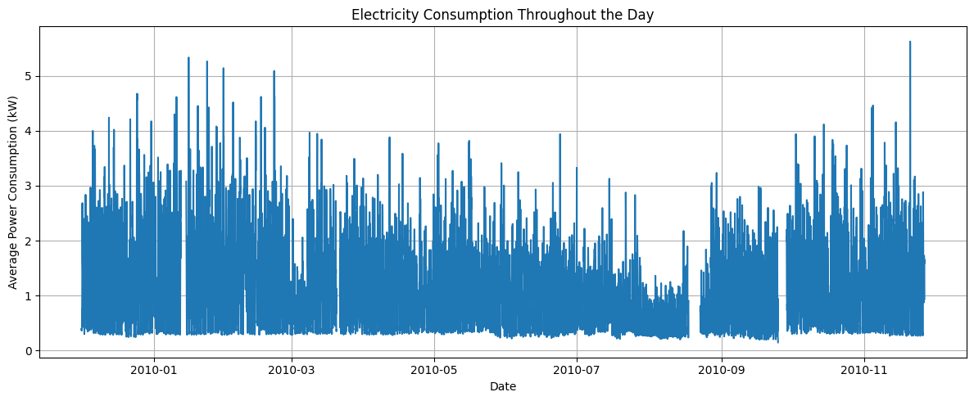
Observation: The average is highest at 20:00 and lowest at 04:00. This identifies the main recurring high- and low-demand hours in this household.

Figure 2. Average active power by weekday
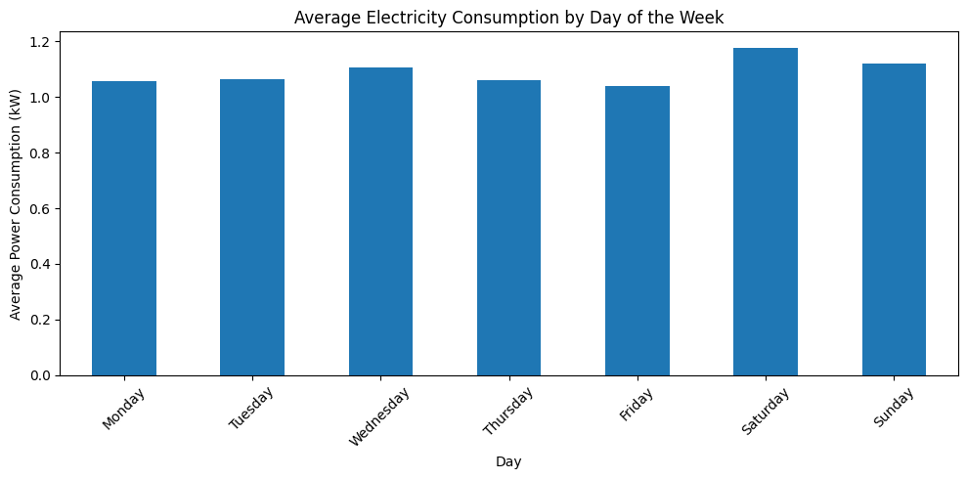
Observation: Saturday has the highest weekday average (1.18 kW), and Friday has the lowest (1.04 kW). The difference is descriptive and applies to this dataset.

Figure 3. Estimated monthly energy consumption
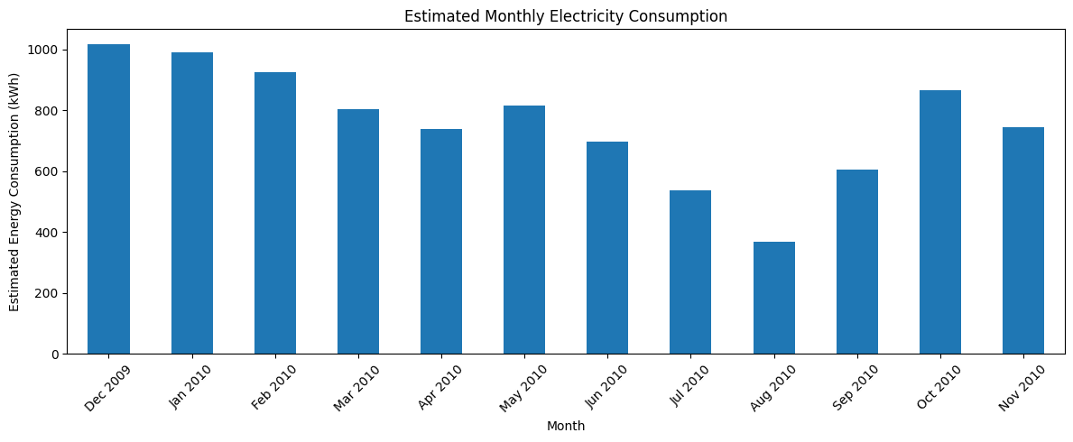
Observation: December 2009 has the highest estimated monthly total, while August 2010 has the lowest. November 2010 is incomplete.

Figure 4. Correlation heatmap
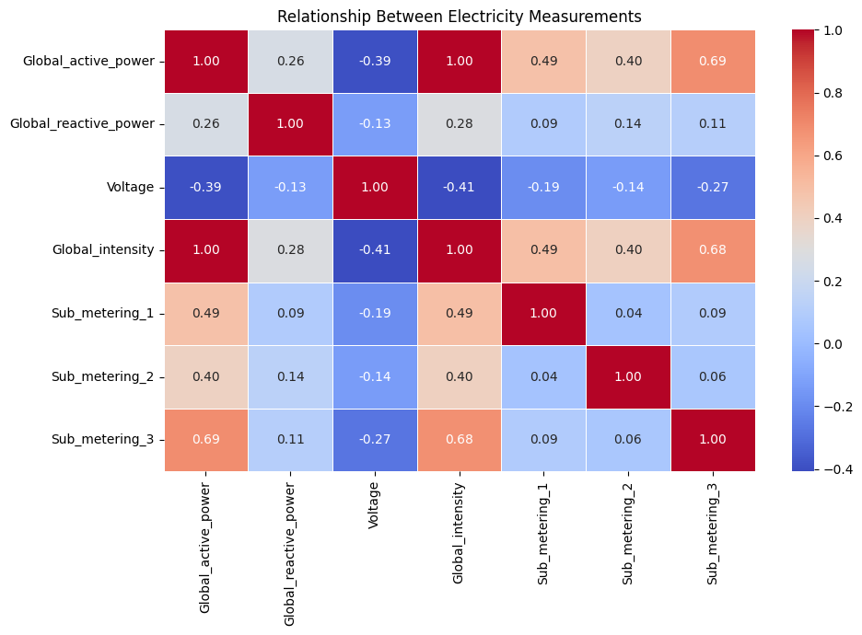
Observation: The heatmap compares relationships between numerical measurements. Correlation shows association and does not establish cause and effect.

6. Statistical Analysis (Basic)

• Basic descriptive statistics were calculated for the selected period. Active power had a mean of 1.09 kW, a median of 0.74 kW, a standard deviation of 0.95 kW, and a range from 0.14 to 9.72 kW. Since the mean is higher than the median, some high-use periods raise the average above the middle observation.
• Voltage had a mean of approximately 241.74 V and a standard deviation of 3.00 V. Global intensity had a mean of 4.58 A. The sub-metering channels had means of about 1.01, 1.11, and 7.36 respectively. These statistics describe the observed measurements only.

Essential code for the descriptive statistics:

print("Electricity Consumption Summary\n")
print("Average power consumption:",
round(df_clean['Global_active_power'].mean(), 2), "kW")
print("Highest power consumption:",
round(df_clean['Global_active_power'].max(), 2), "kW")
print("Lowest power consumption:",
round(df_clean['Global_active_power'].min(), 2), "kW")
print("\nHere is the summary of all measurement columns:")
display(df_clean[numeric_columns].describe().round(2))

• The correlation matrix was also reviewed to see which measurements changed together. No hypothesis test or causal claim was made, because the project’s main purpose was descriptive analysis.

7. Key Insights & Interpretation

• Evening demand: Average active power is highest at 20:00, so this is a useful time to review high-power appliance use.
• Lowest average demand: 04:00 has the lowest hourly average in this period, showing a recurring low-demand time for this household.
• Monthly variation: December 2009 has the highest estimated total and August 2010 the lowest; seasonal and routine differences may contribute, but this analysis does not prove the cause.
• Weekday pattern: Saturday's average is higher than Friday's, suggesting that household routines may differ across the week.
• Sub-metering pattern: Group 3 records the largest total among the three channels, though the channel label alone should not be used to make unsupported appliance-level claims.

8. Conclusion & Future Scope

• This project used Python-based data cleaning, exploratory analysis, descriptive statistics, and charts to study household electricity use. The results show a clear evening peak, lower average use in the early morning, variation across weekdays and months, and a larger recorded total in sub-metering group 3. The dashboard presents these results in a form that is easier to explore.

• The findings should be interpreted carefully because the dataset covers one household in France and November 2010 is incomplete. Monthly energy values are estimates, and the analysis describes patterns rather than proving their causes. The project is useful as a demonstration of how data analytics can make electricity measurements easier to understand.
• Future scope: The project can be improved by comparing complete months only, documenting and validating the energy-estimation formula, and adding clearer data-quality summaries. It could also be extended with data from more households or local smart meters to compare usage patterns across locations. After gathering enough reliable data, a forecasting model could be developed and evaluated on a separate test period. The dashboard could also add date filters and downloadable reports for selected periods.

9. References
1. Hebrail, G., & Berard, A. (2006). Individual Household Electric Power Consumption [Dataset]. UCI Machine Learning Repository: https://doi.org/10.24432/C58K54
2. UCI Machine Learning Repository. Individual Household Electric Power Consumption: https://archive.ics.uci.edu/dataset/235/individual+household+electric+power+consumption
3. pandas development team. pandas documentation: https://pandas.pydata.org/docs/
4. Matplotlib Development Team. Matplotlib documentation: https://matplotlib.org/stable/
5. Streamlit, Inc. Streamlit documentation. https://docs.streamlit.io/

10. AI Tool Usage Declaration

☐ No AI tools were used in this project.
☑ AI tools were used, as detailed below:

AI Tool Used | Purpose (e.g., debugging, documentation) | Extent of Use / Section Applied
ChatGPT | Report wording, explanations, and organization | Used to help draft and revise report text. The student should verify all content and results against the actual project work.

11. Project Links & Deliverables

GitHub Repository Link: https://github.com/ameesatsangi/energy-consumption-dashboard
Python Notebook (.ipynb) File Name: household_power_consumption_google colab project_txt_zip.ipynb
Live Streamlit Dashboard: https://energy-consumption-dashboard-crrdzv2qcrhh9puwb68rhg.streamlit.app/
PBL Report File Name: Data Analytics Report (2)
☑ GitHub repository includes code, notebook, and a PBL report and README

12. Report Structure Checklist (Section 8 Compliance)
S. No. | Report Section (as per Section 8 format) | Included (✓)
1 | Title Page | ✓
2 | Introduction & Problem Statement | ✓
3 | Dataset Description & Source | ✓
4 | Data Cleaning & Preprocessing | ✓
5 | Exploratory Data Analysis (EDA) | ✓
6 | Data Visualization & Observations | ✓
7 | Statistical Analysis (Basic) | ✓
8 | Key Insights & Interpretation | ✓
9 | Conclusion & Future Scope | ✓
10 | References | ✓

13. Declaration by Student(s)

I/We hereby declare that this Mini Project Report is our own original work, prepared using publicly available/open datasets. All sources of data, references, and AI tool assistance have been duly acknowledged. I/We understand that any instance of plagiarism in code or report will attract strict academic action, as per Section 15 of the PBL guidelines.

Team Leader Signature: ___________________
Team Member Signature(s):___________________
Date: ___________________________

14. For Faculty Use Only — PBL Final Report Evaluation
Evaluation Component B — PBL Final Report Submission | Mid-Term (PBL Based): 10 Marks (Section 10 of PBL Guidelines)
Evaluation Criteria | Max Marks | Marks Awarded
Data Cleaning & Preprocessing | 2
Exploratory Data Analysis (EDA) | 2
Visualization & Observations | 2
Statistical Analysis | 2
Insights, Interpretation & Conclusion | 2
Total (out of 10) | 10
Faculty Remarks:

_________________________________________________________________________________

Faculty Mentor Signature:______________________________

Date: ________________________

